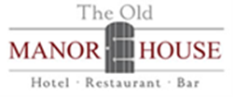

Afternoon Tea at The Old Manor House Hotel
Served Monday to Saturday between 12pm and 5pm
£18.00 per head to include the following:

Selection of meat, fish & vegetarian finger sandwiches
Homemade cakes
A plain & fruit scone with fruit preserve & clotted cream
Dietary requirements and allergies can be catered for; there is a £2.50 supplement per head for vegan and gluten free options
********
Ground Filter Coffee
A selection of herbal teas including green tea, lemon & ginger, chamomile, peppermint, English breakfast & decaffeinated
Please note we require a non-refundable deposit of 50% of your final bill when the booking is made.
Bookings must be made at least 48 hours in advance.
This menu is for up to 10 people, please advise if you would like to see a menu for group afternoon teas.
You can upgrade to a high tea to include a glass of prosecco each.

